EXP 5:a.Simulation and Performance Evaluation of RFID/NFC-Based Device Identification and IoE Data Integration using Node-RED, MQTT
b. Modeling of a 4-Layer IoE Architecture using Node-Red
Objective:
To simulate RFID/NFC-based device identification and integrate the identified device data into a four-layer IoE architecture (Perception, Network, Middleware, Application) using MQTT messaging and a Node-RED style flow, and to evaluate it using tag read rate, identification rate, MQTT delivery rate and end-to-end valid data rate.
Procedure:
- Create a registry of 80 registered RFID/NFC tags (TAG001 to TAG080) and scan 100 tags in total: 80 registered and 20 unregistered (UNKNOWN081 to UNKNOWN100).
- Perception layer: simulate each tag read with a 95% read success probability, assign a random RSSI between -75 and -30 dBm to every successful read, and identify the tag against the registry.
- Network layer: publish each successful read as a JSON message on the MQTT topic ioe/rfid/device, with a 98% delivery probability.
- Middleware layer: accept delivered messages whose device ID is in the registry and reject messages from unknown IDs.
- Application layer: store accepted messages as cloud dashboard records.
- Compute the performance metrics and plot the data flow, identification results, MQTT delivery and RSSI distribution.
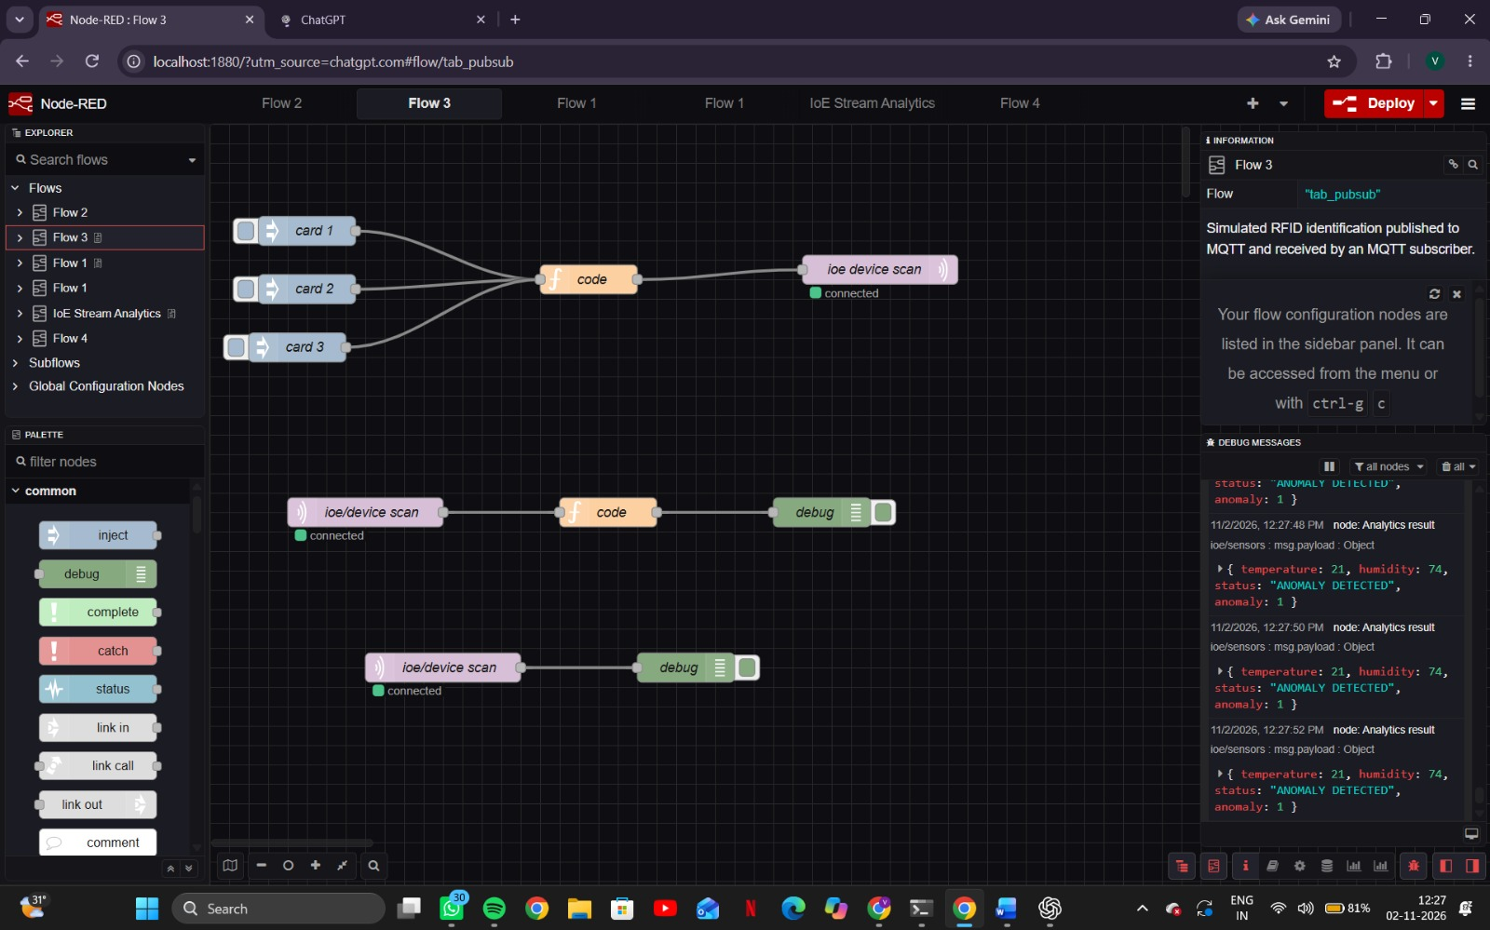
Output: node Fig. 1: Console output of the simulation (four layers and performance results)

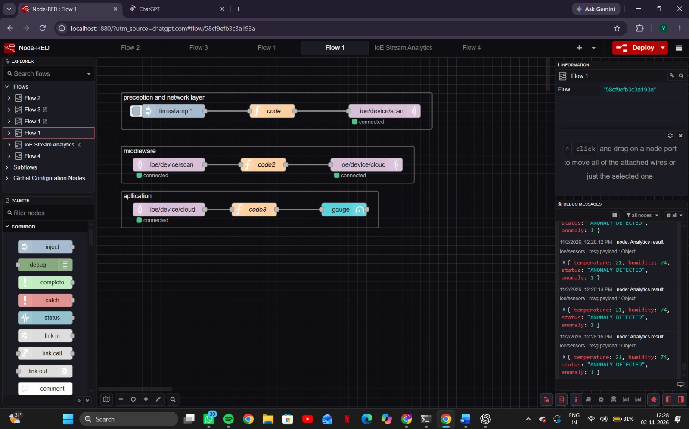
Fig. 2: Cloud dashboard - sample records
Results:
IoE layer | Measure | Count
Perception | Tag scan attempts | 100
Perception | Successful tag reads | 94
Perception | Registered devices identified | 77
Network | MQTT messages published / delivered / lost | 94 / 92 / 2
Middleware | Valid messages processed / unknown rejected | 76 / 16
Application | Dashboard records (unique devices) | 76 (76)

Metric | Value
RFID read success rate | 94.00% (94 of 100)
Registered identification rate | 77.00% (77 of 100)
MQTT delivery rate | 97.87% (92 of 94)
End-to-end valid data rate | 76.00% (76 of 100)

Of the 100 scans, 6 failed to read and 17 of the successful reads were unregistered tags. Two MQTT messages were lost (one registered, one unknown), so 76 registered devices (of 77 identified) and 16 unknown devices reached the middleware. The 16 unknown IDs were rejected, and the remaining 76 valid messages appeared on the dashboard. RSSI values are spread across -75 to -30 dBm.
Result:
The simulated four-layer IoE system identified registered RFID/NFC devices and delivered their data end to end with a 76.00% valid data rate. The read success rate (94.00%) and MQTT delivery rate (97.87%) were close to the configured 95% and 98%, and the middleware correctly rejected every unknown tag, which shows that registry-based validation protects the dashboard from unregistered devices. The main losses came from unregistered tags (20% of the scanned set) and read failures rather than from the network. All values are simulated, not measured from hardware.

